TEST PLAN

<<Heroes Test Plan>>

Abstract

This document provides an overview of the project and the product test strategy, a list of testing deliverables and plan for development

# VERSION HISTORY

|  |  |  |  |  |  |
| --- | --- | --- | --- | --- | --- |
| **Version**  **#** | **Write by** | **Revision Date** | **Approved By** | **Approval Date** | **Outline** |
| 1.0 | *Mounir Youssef* | *24-07-2019* | *Mounir* | *24-07-2019* | Test Plan create |
|  |  |  |  |  |  |
|  |  |  |  |  |  |

**TABLE OF CONTENTS**

VERSION HISTORY 3

INTRODUCTION 5

1 TEST STRATEGY 5

1.1 Scope of Testing 5

1.1.2 Feature not to be tested 5

1.2 Test Type 5

1.3 Risk and Issues 6

1.4 Test Logistics 6

1.4.1 Who will test? 6

1.4.2 When will test occur? 6

2 TEST OBJECTIVE 6

3 TEST CRITERIA 6

3.1 Suspension Criteria 6

3.2 Exit Criteria 6

4 RESOURCE PLANNING 7

4.1 System Resource 7

4.2 Human Resource 7

5 TEST ENVIRONMENT 8

6 SCHEDULE & ESTIMATION 8

6.1 All project task and estimation 8

6.2 Schedule to complete these tasks 9

7 TEST DELIVERABLES 9

7.1 Before testing phase 9

7.2 During the testing 9

7.3 After the testing cycles is over 9

- Release notes 9

## INTRODUCTION

The Test Plan is designed to prescribe the scope, approach, resources, and schedule of all testing activities of the project Heroes web site.

The plan identify the items to be tested, the features to be tested, the types of testing to be performed, the personnel responsible for testing, the resources and schedule required to complete testing, and the risks associated with the plan.

## TEST STRATEGY

### Scope of Testing

* + 1. **Feature to be tested**

All the feature of Heroes we site which were defined in software requirement specs are need to bested

|  |  |  |
| --- | --- | --- |
| **Module Name** | **Applicable**  **Roles** | **Description** |
| **Dashboard** | All | * Top 4 heroes should be displayed. * User will be able to search a hero. * All notification e=messages should be tracked and available in the down section for the dashboard * User can click on a hero to see more details, user will be directed to the hero details page |
| **Heroes list** | All | * List all heroes (id, full name) * Search an Hero * Delete an horos * Log transactions in the messages section |
| **Hero details** | All | * Display horo details (full name, id). * User should be able to update the hero name. * User should be able to go back to the previous screen * Log all transactions applied to a hero |
| **Messages** | All | * This screen should be placed in all main screens * Log all transactions from all screens * User should be able to clean the messages any time and from any screen |

### Feature not to be tested

These feature are not be tested because they are not included in the software requirement specs

* + - * Database logical
      * Website Security , load and Performance

### Test Type

In the project Heroes we site, there’re 3 types of testing should be conducted.

* + - **Integration** Testing (Individual software modules are combined and tested as a group)
      * **System** Testing: Conducted on a **complete**, **integrated** system to evaluate the system's compliance with its specified requirements
      * **API testing:** Test all the APIs create for the software under tested

### Risk and Issues

|  |  |
| --- | --- |
| **Risk Mitigation** | |
| **Team member lack the required skills for website testing.** | Plan **training course** to skill up your members |
| **The project schedule is too tight; it's hard to complete this project on time** | Set **Test Priority** for each of the test activity. |
| **Test Manager has poor management skill** | Plan leadership training for manager |
| **A lack of cooperation negatively affects your employees' productivity** | **Encourage** each team member in his task, **and**  **inspire** them to greater efforts. |
| **Wrong budget estimate and cost overruns** | Establish the scope before beginning work, pay a lot of attention to project planning and constantly track and measure the progress |

### Test Logistics

### Who will test?

The project should use **outsource** members as the tester to save the project cost

### When will test occur?

The tester will start the test execution when all the following inputs are ready

* + - Software is available for testing
    - Test Specification is created
    - Test Environment is built
    - Enough human resource for testing

## TEST OBJECTIVE

The test objectives are to **verify** the Functionality of website Heroes web site, the project should focus on testing the **heroes management** such as heroes dashboard, hero details, and transactions…etc. to **guarantee** all these operations can work **normally** in real business environment.

## TEST CRITERIA

### Suspension Criteria

If the team members report that there are **40%** of test cases **failed**, suspend testing until the development team fixes all the failed cases.

### Exit Criteria

Specifies the criteria that denote a **successful** completion of a test phase

* + - **Run** rate is mandatory to be **100%** unless a clear reason is given.
    - **Pass** rate is **80%,** achieving the pass rate is **mandatory**.

## RESOURCE PLANNING

### System Resource

|  |  |  |
| --- | --- | --- |
| **No.** | **Resources** | **Descriptions** |
| **1.** | Server | Need a Database server which install MySQL server Web server which install Apache Server |
| **2.** | Test tool | Develop a Test tool which can auto generate the test result to the pre- defined form and automated test execution |
| **3.** | Network | Setup a LAN Gigabit and 1 internet line with the speed at least 5 Mb/s |
| **4.** | Computer | At least 4 computer run Windows 7, Ram 2GB, CPU 3.4GHZ |

### Human Resource

|  |  |  |  |
| --- | --- | --- | --- |
| **No.** |  | **Member** | **Tasks** |
| **1.** | Test Manager | | Manage the whole project Define project directions Acquire appropriate resources |
| **2.** | Test |  | Identifying and describing appropriate test techniques/tools/automation architecture  Verify and assess the Test Approach  Execute the tests, Log results, Report the defects. Outsourced members |
| **3.** | Developer in Test | | Implement the test cases, test program, test suite etc. |
| **4.** | Test Administrator | | Builds up and ensures test environment and assets are managed and maintained  Support Tester to use the test environment for test execution |
| **5.** | SQA members | | Take in charge of quality assurance  Check to confirm whether the testing process is meeting specified requirements |

## TEST ENVIRONMENT

The Test Environment should be setup as figure below

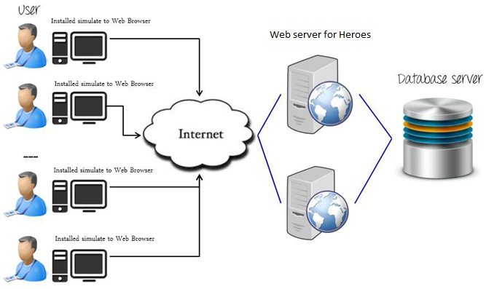

## SCHEDULE & ESTIMATION

### All project task and estimation

|  |  |  |
| --- | --- | --- |
| **Task** | **Members** | **Estimate effort** |
| **Create the test specification** | Test Designer | 170 man-hour |
| **Perform Test Execution** | Tester, Test Administrator | 80 man-hour |
| **Test Report** | Tester | 10 man-hour |
| **Test Delivery** |  | 20 man-hour |
| **Total** |  | **280 man-hour** |

### Schedule to complete these tasks

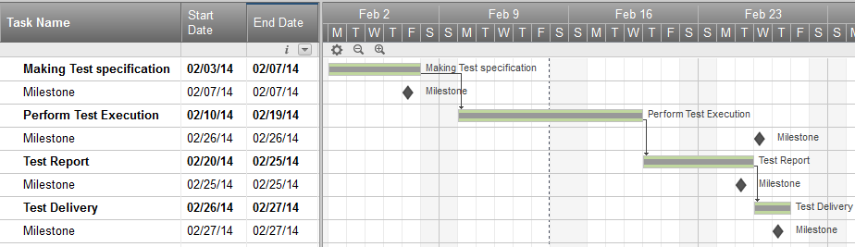

## TEST DELIVERABLES

Test deliverables are provided as below

### Before testing phase

* + - Test plans document.
    - Test cases documents
    - Test Design specifications.

### During the testing

* + - Test Tool
    - Simulators.
    - Test Data
    - Test Trace-ability Matrix
    - Error logs and execution logs.

### After the testing cycles is over

* + - **Test Results/reports**
    - Defect Report
    - Installation/ Test procedures guidelines

### Release notes